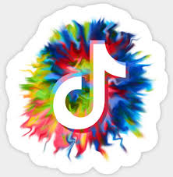

**COACH CALHOUN’S CHALLENGE ACTIVITY FOR THE WEEK OF APRIL 13-17 :**

**Physical Education Standard 2:**

Students demonstrate knowledge of movement concepts, principles, and strategies that apply to the learning and performance of physical activities.

**Learning Target:**

I can change speeds in response to tempos, rhythms, and signals while traveling in straight, curved, and zigzag pathways, using the following locomotor movements: walking, running, leaping, hopping, jumping, galloping, sliding, and skipping.

**Success Criteria:**

I can demonstrate my ability to apply coordinated physical movements in sync with rhythmic beats by posting my challenge performance to Coach Calhoun’s Tik Tok challenge page.